 Pegasys
[Office Defaults]

- Pegasys allows users to create an Office Code that represents their office information (name, address, phone number, fax, etc.). With the Office Defaults function, this code is pre-entered in the address field so that when a document is opened that uses that office information, it will already be populated. The user will not have to manually enter the office information.

Figure 1
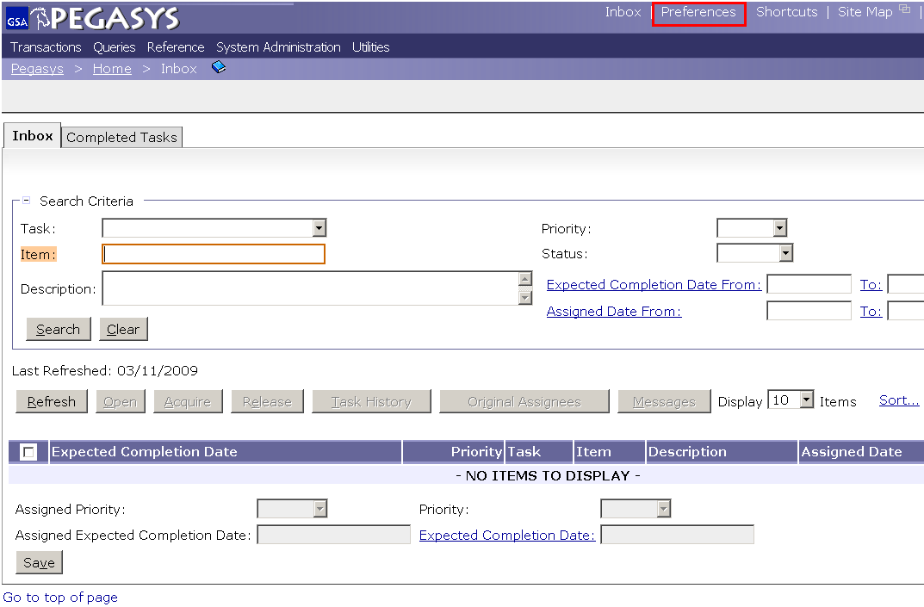
Figure 1

- From the Pegasys homepage, click on Preferences in the upper right-hand corner
Figure 2

- Click the Office Defaults tab that’s outlined in red
- Click the Add button
Figure 2
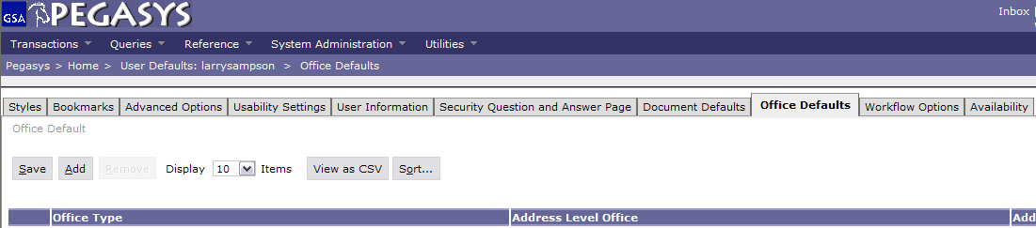

Figure 3

- Select the Office Type from the drop-down list
- Fill in the Default Office. Search by clicking the Favorites Icon “” or the Default Office link
- Click Save when finished

Figure 3
